Compute Cluster with ORM stack

Contents

1. Introduction 3
2. Workflow diagram to deploy the stack 3
3. Create stack for Compute cluster 4
4. Plan the Job 8
5. Apply the Job 9
6. Destroy the stack 10

Introduction

A compute cluster is a group of high performance computing (HPC), GPU, or optimized instances that are connected with a high-bandwidth, ultra low-latency network. Each node in the cluster is a bare metal machine located in close physical proximity to the other nodes. A remote direct memory access (RDMA) network between nodes provides latency as low as single-digit microseconds, comparable to on-premises HPC clusters.

Workflow diagram to deploy the stack

Below diagram shows how the Terraform Artifact are applied in the OCI. While creating a ORM stack, using terraform deliverables Init, Plan and Apply is the flow to provision the resource in the OCI. We can have the deliverables in any of below.

- GitLab/GitHub Repo
- Bitbucket
- Can be in folder/.zip in the local disk
- Object Storage Bucket
- Can be in compartment
- Oracle provided Template

Supported Shapes:
• BM.HPC2.36
• BM.GPU.A100-v2.8
• BM.GPU4.8
• BM.Optimized3.36
To create a compute cluster, user need to create an empty RDMA network group and then use the compute cluster’s OCID with the Launch Instance operation to create instances in the compute cluster.

Create stack for Compute cluster
Go to OCI Console Developer Services Resource Manager Stacks select the compartment Create Stack

My Configuration Folder Browse Select the “compute cluster” folder that contains the terraform Upload

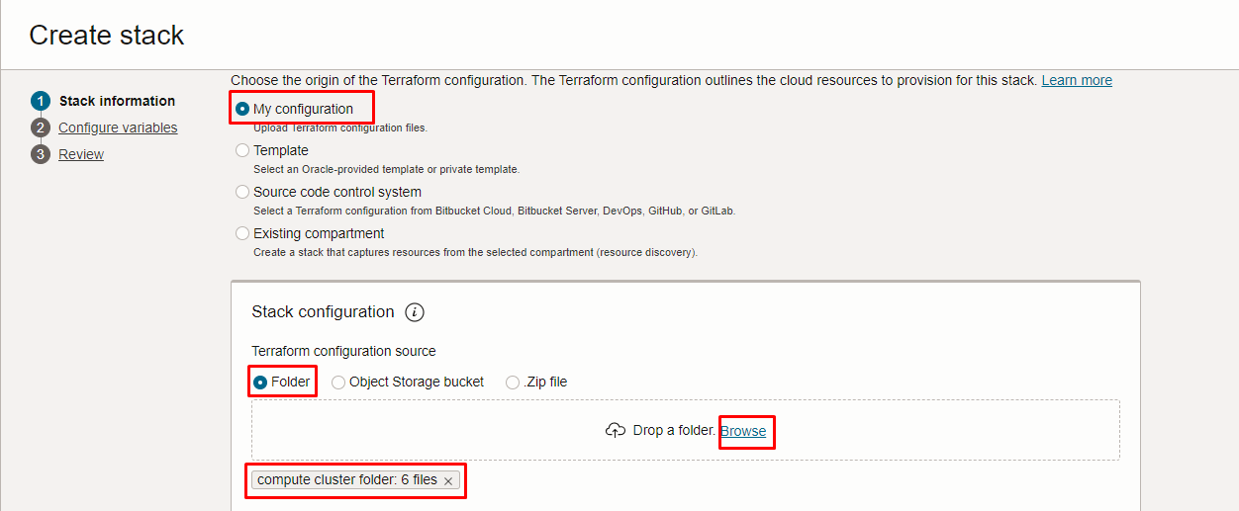
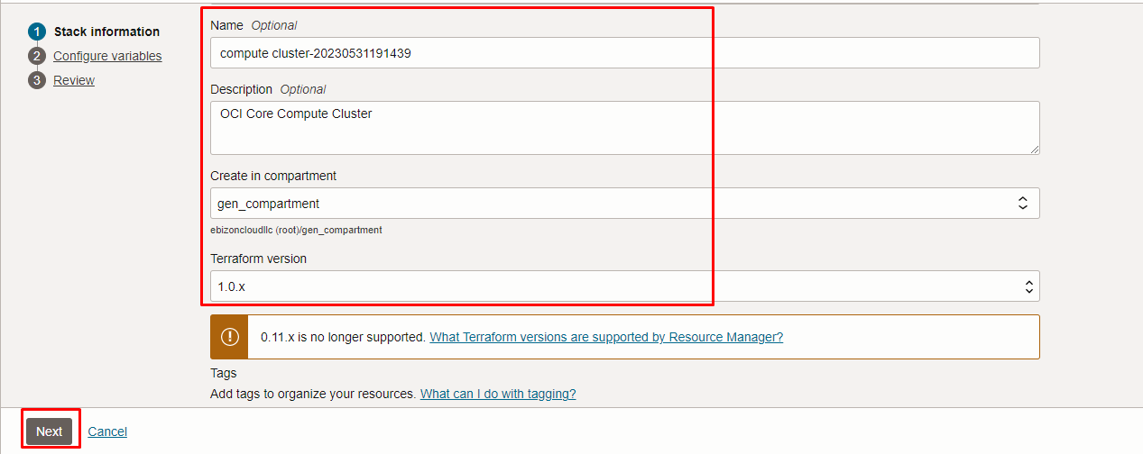
Click “NEXT”
Select the parameters as per the below screen,
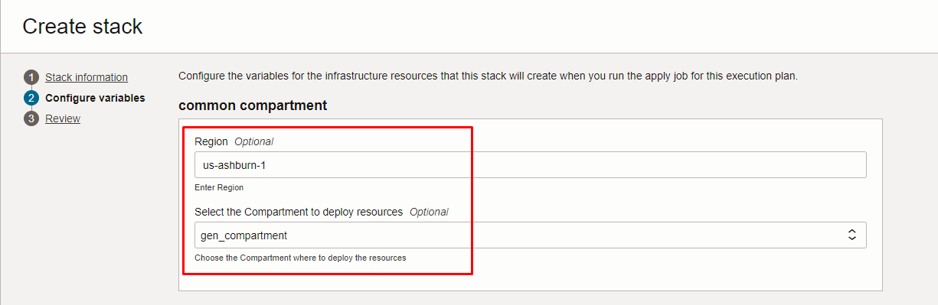

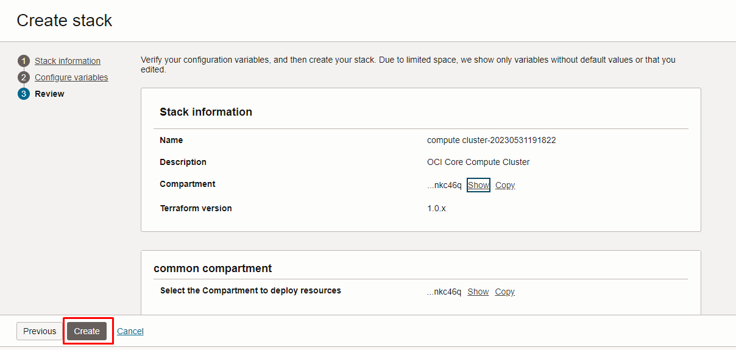
Click “NEXT” Click “CREATE”

Plan the Job

Click the “Plan”
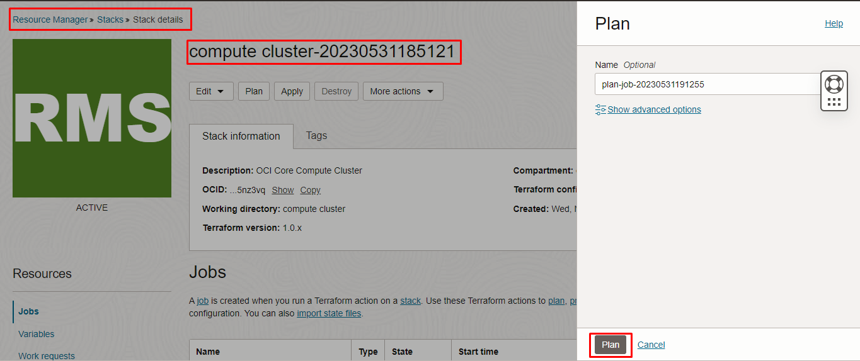
Verify the Plan is successful.
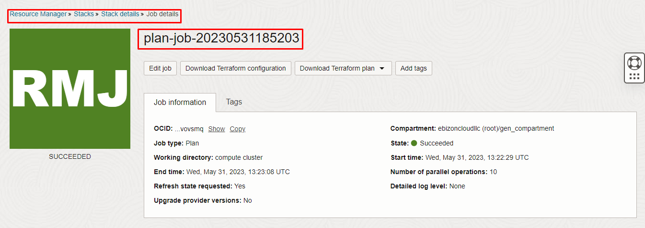
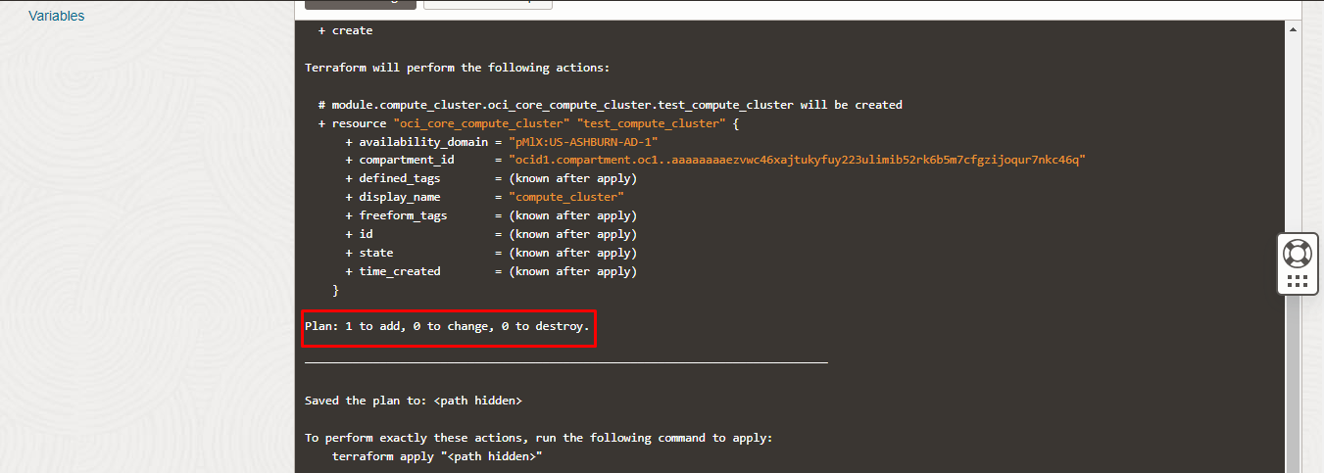

Apply the Job
Once the “plan” is success, now click “Apply”

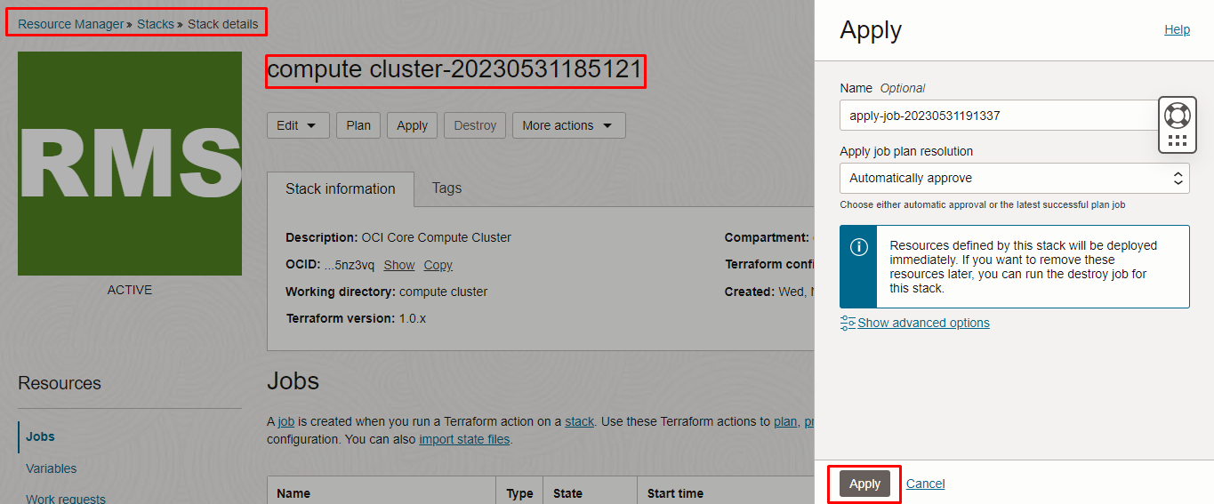
Verify the Apply is successful
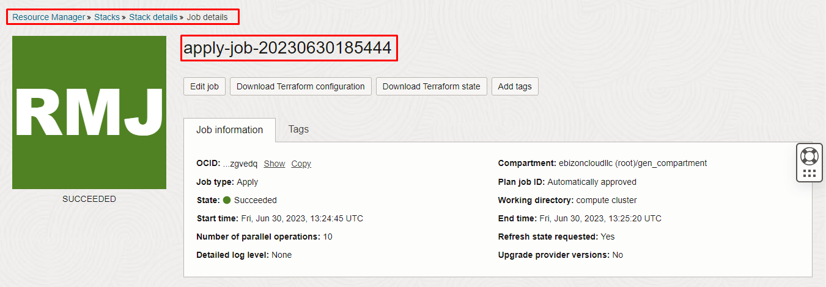
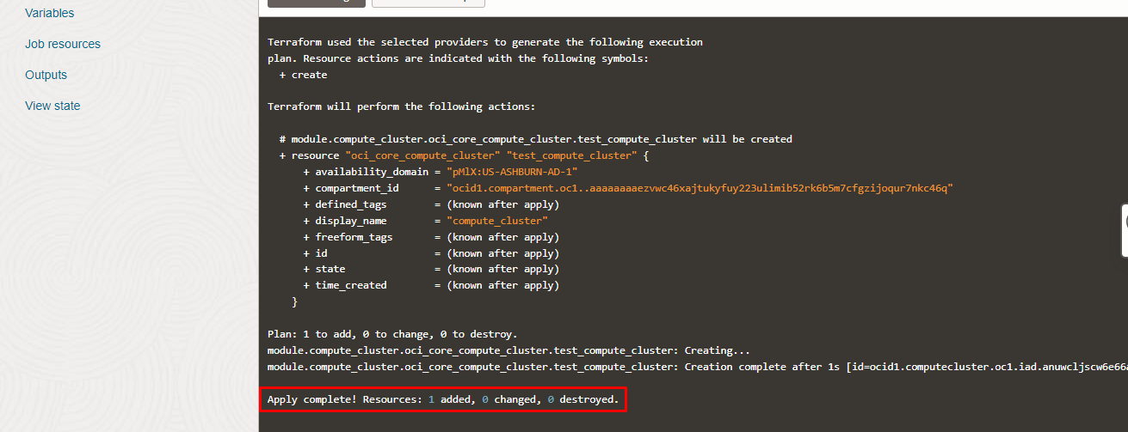

Verify in the Console

Go to OCI Console Compute Compute Cluster
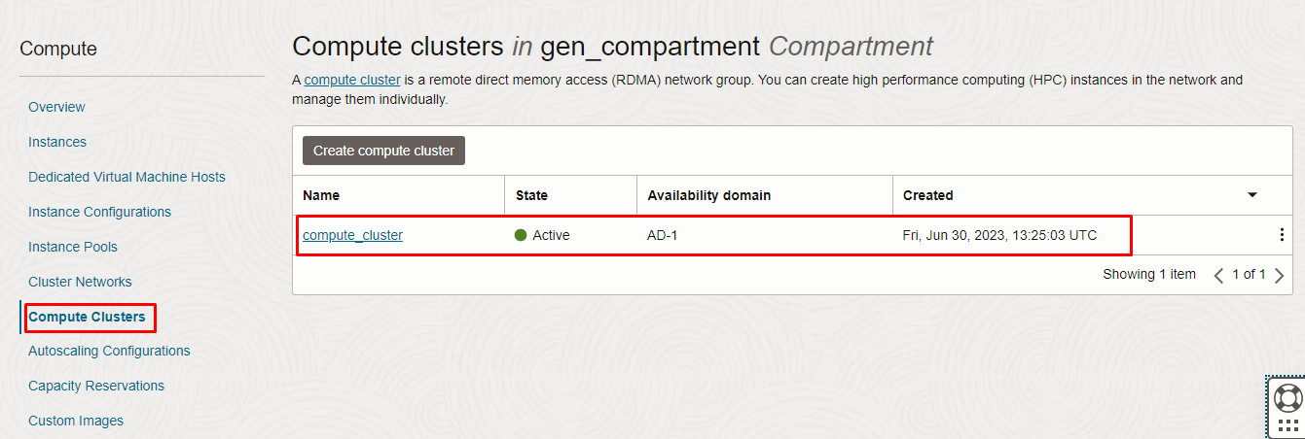


Destroy the stack
Create a destroy job in Resource Manager to release resources associated with a stack and clean up the tenancy. Once destroyed data cannot be recovered from resources.
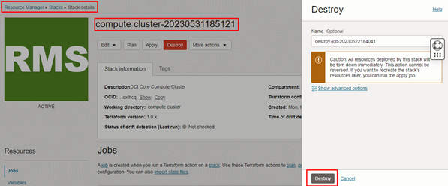
###END###

